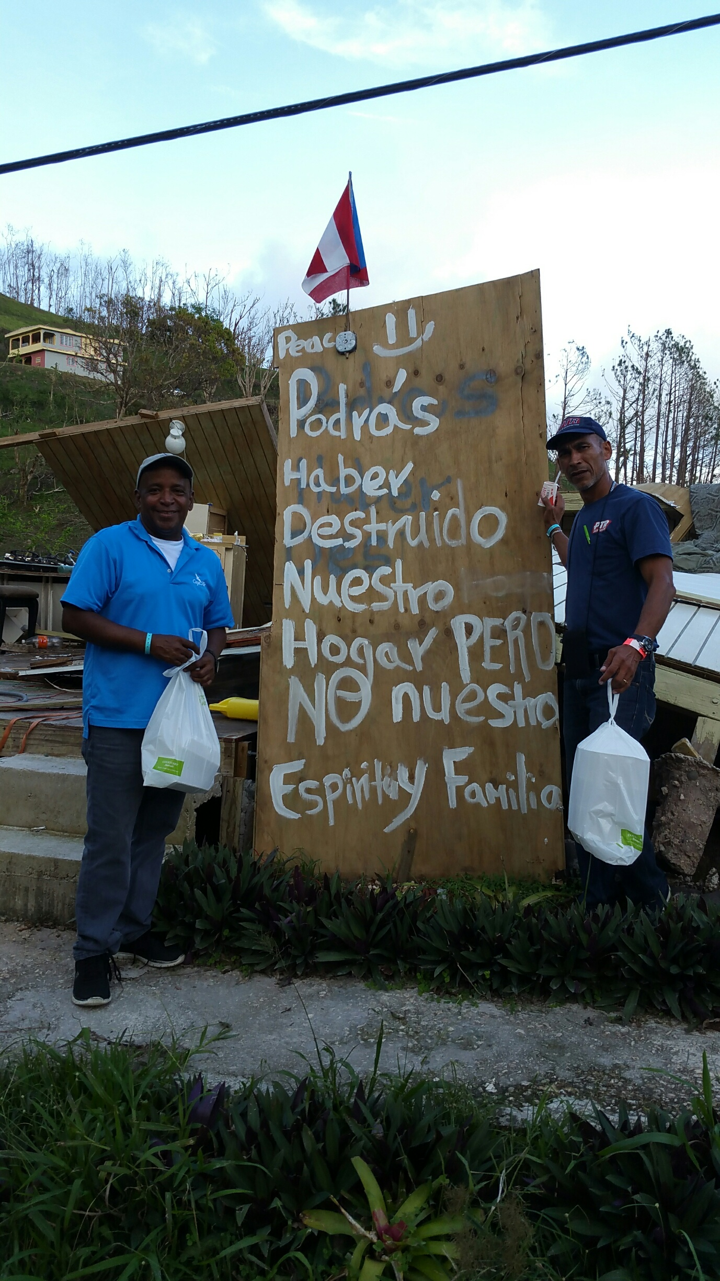

You could have destroyed our home but not our spirit and family.